
Undergraduate Final Year Project Proposal

Use of NodeJS, ReactJS and MongoDB to build a music social website

Phung Tan Sang

Bachelor of Science with Honors in Computing

001247397

Assessor’s name: Ho Nguyen Phu Bao
Learner’s name: Phung Tan Sang
Student ID: GCS190084
Banner ID: 001247397
Class: TCS2203
Subject code: COMP1682

Table Contents
1 Overview 3
2 Aim 3
3 Objectives 3
4 Legal, Social, Ethical and Professional 4
5 Planning 5
6 References 6

Overview
Nowadays, the world is gradually turning to digital technology which is 4.0. It helps commercial activities, education, entertainment needs become faster, more flexible, and diverse. Of course, that's why websites, apps, games, ... are strongly developed.

My project is also a simple website about a music social network to bring relaxation, entertainment, and convenience to users during stress or tired days. Besides, Nodejs is a flexible, fast-growing language I chose to develop this website. It can easily create as many themes as I want. In addition, I have researched ReactJS that is a framework. Not only that, it is a full library of luxurious theme support for this project because of its convenience and completeness. It will help me create a music website with a dynamic interface and easy maintenance. This website will allow users to post music with the words they want to share. In addition, they can add music they feel like to private playlists. Of course, those are the main functions that I want to bring to everyone. Finally, I hope that the website will give users the best experience.

Aim
The idea of ​​​​creating my music website is based on minimizing the limitations and influences on other social networking platforms. The website allows users to listen to music accompanied by posting a few words, a paragraph or a story to share feelings, find harmony from everyone. It creates a stronger bond if everyone has the same cheerful, quiet or gentle melodies to relieve stress, creating a joyful, positive environment. I want to be able to help people create their own playlists so they don't have to spend a lot of time searching for songs they've heard. The purpose of building a simple music website is as optimized as possible to bring the best experience to users including entertainment, relaxation and sharing emotions through status lines. Finally, I want to apply 2 technologies, NodeJS and ReactJS to this system.

Objectives
3.1 Website Programming
3.1.1 Research on social media websites (Facebook, Zingmp3, etc…).
3.1.2 Research the steps of completing website.
3.1.3 Plan to build a social media website.
3.2 NodeJS and ReactJS
3.2.1 Learn and research about OOP.
3.2.2 Learn about NodeJS data structure.
3.2.3 Research on NodeJS related to website.
3.2.4 Learn about ReactJS library.
3.2.5 Study how NodeJS and ReactJS work on server.
3.2.6 Study about data optimization.
3.3 Research on feature and user interface.
3.3.1 Research on interface of other social media websites.
3.3.2 Research on some features on others website as same.
3.3.3 Research on current music trends of users.
3.4 Objective noun
3.4.1 Build website ideas and flow.
3.4.2 Functional design for website.
3.4.3 Design website interface.
3.4.4 Deploy website on the server.

Legal, Social, Ethical and Professional

Legal:
- Tools and technologies are used in my website are free on the Internet.
- Material sources are researched from sources.
- I and Greenwich University both own this initiative.
Social:
- This website is designed to satisfy everyone's entertainment needs and does not involve any illegal activities.
- Many music sources are used from around the world which will be not used for business.
- My project just only helps me for studying and researching.
Ethical:
- My efforts and perseverance are reflected in this project.
- The project is not related to plagiarism.
Professional:
- Disclosure is not permitted and is disclosed or used for personal purposes or for the benefit of third parties except as permitted by the University of Greenwich or the Law.
- Respect alternative perspectives and honest critique of my project.
- Avoid conflicts between my interests and the authorities.

Planning

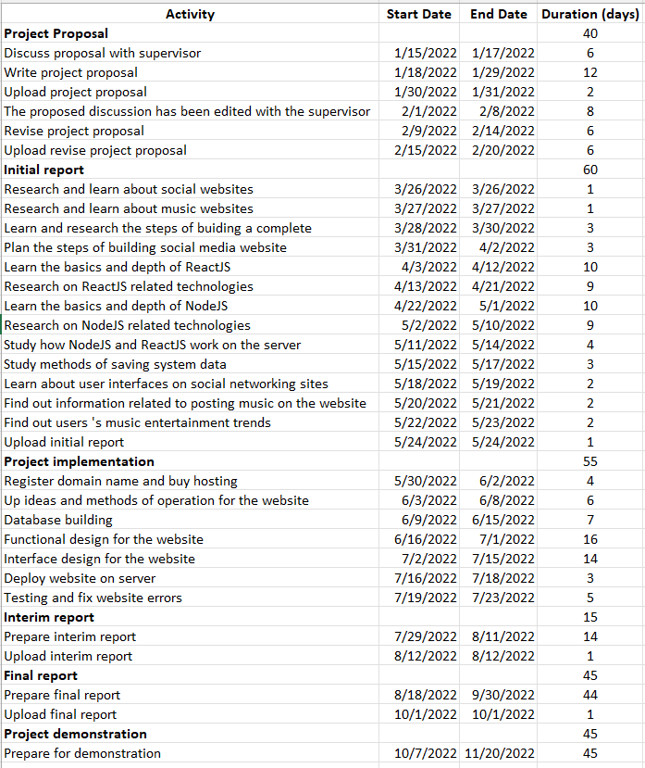
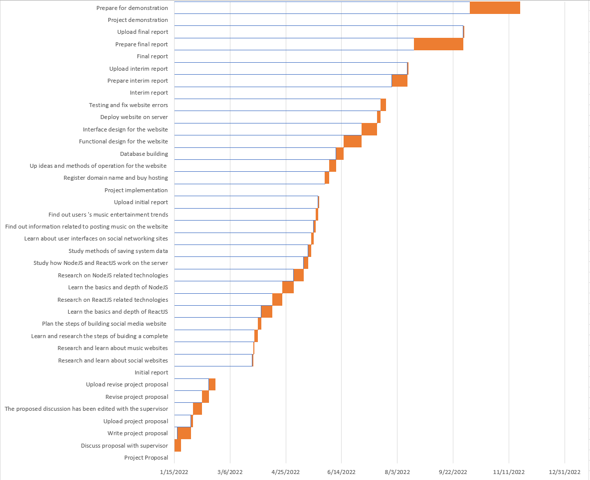

References

- Amuta Deshpande (2022). 7 Advantages of ReactJS for Building Interactive User Interfaces. [online] Available: https://www.clariontech.com/blog/7-advantages-of-reactjs-for-building-interactive-user-interfaces [Accessed 15 Jan.2022]
- Taha Sufiyan (2022). What is Node.js: A Comprehensive Guide. [online] Available: https://www.simplilearn.com/tutorials/nodejs-tutorial/what-is-nodejs [Accessed 16 Jan.2022]
- Nikita Duggal (2022). All You Need To Know About MERN Stack. [online] Available: https://www.simplilearn.com/tutorials/mongodb-tutorial/what-is-mern-stack-introduction-and-examples [Accessed 16 Jan.2022]
- Ju’s Gate (2021). Difference Between CSS and SCSS. [online] Available: https://byjus.com/gate/difference-between-css-and-scss/ [Accessed 20 Jan.2022]
- Alina Rovnaya (2022). What is a Social Media Website and When Do You Need It?. [online] Available: https://www.cleveroad.com/blog/how-to-create-a-social-media-website/ [Accessed 20 Jan.2022]
- Jack Vaughan (2020). DEFINITION MongoDB. [online] Available: https://www.techtarget.com/searchdatamanagement/definition/MongoDB [Accessed 21 Jan.2022]
- Summer ye (2019). Complete Beginner's Guide on How to Learn UI Design. [online] Available: https://www.mockplus.com/blog/post/learn-ui-design [Accessed 21 Jan.2022]
- Rebecca Taylor(2017). 8 Benefits of Listening to Music. [online] Available: https://www.kent-teach.com/Blog/post/2017/06/29/8-benefits-of-listening-to-music.aspx [Accessed 10 Jan.2022]
- Divine You (2018). Why is Entertainment Important in Our Life?. [online] Available: https://divineyouwellness.com/blog/why-is-entertainment-important-in-our-life/ [Accessed 10 Jan.2022]
- FSD Staff (2021). WHAT ARE THE TOP 6 ENTERTAINMENT PLATFORMS ONLINE?. [online] Available: https://www.fakeshoredrive.com/2021/08/what-are-the-top-6-entertainment-platforms-online.html/ [Accessed 12 Jan.2022]

